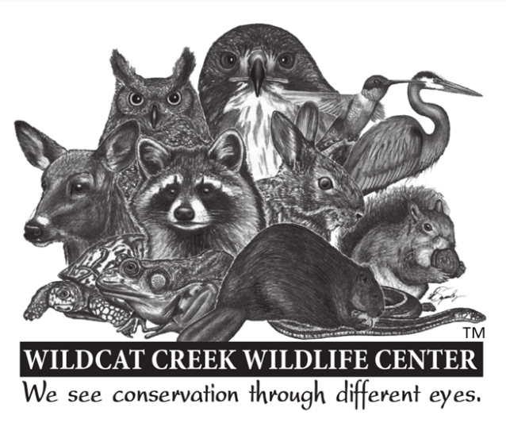
Wildcat Creek Wildlife Center, Inc.
4709 N 400 W
Delphi, IN 46923
(765) 491-2351

Dear Friend of WCWC;

Thank you for inquiring about volunteering with the Wildcat Creek Wildlife Center (WCWC). We always need more volunteers and encourage your interest.

WCWC is a conservation organization and its mission is to foster awareness and appreciation of Indiana’s native wildlife. Our services involve the rehabilitation of injured and orphaned native wild animals and education to the public.

WCWC is a charity that was founded in 1995 by Carol Blacketer, the organization’s Executive Director. Dedicated volunteers and interns perform virtually all daily activities of the organization.

The minimum service commitment is 16 hours per month. Many volunteers start by working as a caretaker but as volunteers gain skills and familiarity with WCWC and wildlife, those who wish to can do voluntary service at home through raising orphans, performing administrative tasks, and computer data entry.

You do not need previous experience working with animals to volunteer at WCWC, and in fact, one of WCWCs goals is to give people this experience. WCWC conducts a number of workshops for volunteers and volunteers are also given “on the job” training as they work. There are also State and National Conferences on wildlife rehabilitation that a number of our volunteers attend.

WCWC operates as an emergency response center for wildlife. This can be a demanding voluntary service and requires the development of a number of skills. We ask that volunteers be willing to spend a fair amount of time learning about wildlife, first aid, and be able to follow through with the commitments they make to WCWC. Volunteers must also be able to relate well to people. We also ask potential volunteers to understand that work with wild animals is different than work with pets and domestics and that WCWC’s objective is not to “save all the animals”. Wild animals at WCWC are not tamed or kept as pets. Only those wild animals which are the best candidates for release back into the wild are selected for rehabilitation, the rest are euthanized. And only a select few are able to be in an educational ambassador program.

WCWC will provide you with a unique opportunity to “think globally and act locally” on behalf of wildlife conservation. You will learn more than you can now imagine about the diversity of wildlife and you will become an effective spokesperson on behalf of wild animals as one of our volunteers.

If you decide that you do not want to commit to the time needed to volunteer for WCWC, we ask that you consider donating money or supplies to help support the efforts of the dedicated volunteers of WCWC.

If you are ready, download the volunteer application, print it out, fill it out, and send it to the center at the Delphi address listed above. Once we have received your application we will arrange for an interview with you. After that we will see you in the Center!

Please contact us at (765) 491-2351 if you have any questions about the volunteer application.

