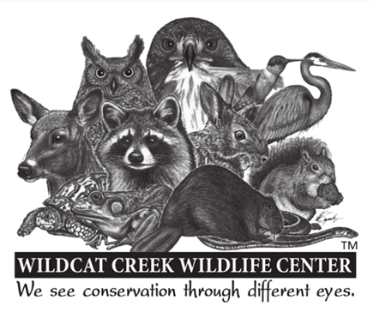**Wildlife rehabilitation internship: Indiana**

Agency Wildcat Creek Wildlife Center

Location Delphi, Indiana

Job Category Internships

Salary n/a

Start Date 01/01/2023

End Date 12/31/2023

Website <http://www.wildcatwildlifecenter.org>

Qualifications Applicants should be enrolled in or recent graduate from a related field of study

How to Apply Submit cover letter and resume to Denise Hays, Facility Director [dlhays59@hotmail.com](mailto:dlhays59@hotmail.com)

Description

Wildcat Creek Wildlife Center is a wildlife rehabilitation and hospital facility located in Indiana. Annually we admit nearly 2000 wildlife patients of all native and migratory species. Interns work with song birds, woodpeckers, waterfowl, birds of prey, reptiles and amphibians. Mammal species include white tailed deer, raccoon, opossum, fox, coyote, mink, bobcat, skunk, woodchuck, muskrat, five species of squirrel and bats. Indiana has a very low occurrence of rabies so a pre-exposure rabies vaccine is not a requirement for this internship. Bats are the only species interns are not allowed to work with unless they have a pre-exposure rabies vaccine.

Interns work hands-on with over 100 different species and learn several different feeding techniques, preparation of species specific formulas, have the opportunity to read radiographs, observe surgeries, and participate in postoperative care under the direct supervision of our medical staff.

Other responsibilities include animal husbandry, enrichment, diet prep, hospital hygiene, recordkeeping, admission and triage of new patients. Work is conducted inside as well as outside in all kinds of weather and can be physically demanding. Interns work in a fast paced, high stress, multitasking, challenging environment.

We are looking for interns that can enthusiastically work 60 to 70 hours a week. The work week consists of five 12 to 14 hour days and two days off per week. This is an unpaid internship as noted above, however we do have housing available at the center. Minimum time commitment is 10 weeks. All interns must be fully vaccinated for Covid.



To apply, please send a cover letter and resume to Denise Hays, Facility Director at [dlhays59@hotmail.com](mailto:dlhays59@hotmail.com). Please indicate the time period you are interested in (Spring, Summer, Annual) and your available start dates.